Detection and attribution of an anomaly in terrestrial photosynthesis in Europe during the COVID-19 lockdown

Running title: Gross photosynthesis during COVID-19 lockdown
Angela Che Ing Tang^{1*}, Christophe Flechard², Nicola Arriga³, Dario Papale^{4,5}, Paul C. Stoy⁶, Nina Buchmann⁷, Matthias Cuntz⁸, John Douros⁹, Silvano Fares¹⁰, Alexander Knohl¹¹, Ladislav Šigut¹², Guillaume Simioni¹³, Renske Timmermans¹⁴, Thomas Grünwald¹⁵, Andreas Ibrom¹⁶, Benjamin Loubet¹⁷, Ivan Mammarella¹⁸, Luca Belelli Marchesini¹⁹, Mats Nilsson²⁰, Matthias Peichl²⁰, Marius Schmidt²¹, Christian Bernhofer¹⁵, Daniel Berveiller²², Edoardo Cremonese²³, Tarek S. El-Madany²⁴, Mana Gharun^{7,25}, Damiano Gianelle¹⁹, Lukas Hörtnagl⁷, Marilyn Roland²⁶, Andrej Varlagin²⁷, Bernard Heinesch²⁸, Ivan Janssens²⁶, Natalia Kowalska¹², Jiří Dušek¹², Giacomo Gerosa²⁹, Meelis Mölder³⁰, Eeva-Stiina Tuittila³¹, Denis Loustau¹

¹ISPA, Bordeaux Sciences Agro, INRAE, Villenave d’Ornon, France
²UMR SAS, INRAE, Institut Agro, Rennes, France
³Joint Research Centre, European Commission, Ispra, Italy
⁴University of Tuscia DIBAF, Viterbo, Italy
⁵EuroMediterranean Center on Climate Change. CMCC IAFES, Viterbo, Italy
⁶Department of Biological Systems Engineering, University of Wisconsin-Madison, Madison, WI, USA
⁷Department of Environmental Systems Science, ETH Zurich, Zurich, Switzerland
⁸Université de Lorraine, AgroParisTech, INRAE, UMR Silva, Nancy, France
⁹Royal Netherlands Meteorological Institute (KNMI), De Bilt, the Netherland
¹⁰CNR-National Research Council, Rome, Italy
¹¹Bioclimatology, University of Göttingen, Göttingen, Germany
¹²Department of Matter and Energy Fluxes, Global Change Research Institute of the Czech Academy of Sciences, Brno, Czech Republic
¹³URFM, INRAE, Avignon, France
¹⁴Climate Air and Sustainability Unit, Netherlands Organisation for Applied Scientific Research (TNO), Utrecht, the Netherlands
¹⁵Faculty of Environmental Sciences, Institute of Hydrology and Meteorology, Technische Universität Dresden, Tharandt, Germany
¹⁶Technical University of Denmark (DTU), DTU-Sustain, Kgs. Lyngby, Denmark
¹⁷UMR ECOSYS, AgroParisTech, INRAE, Université Paris-Saclay, Thiverval-Grignon, France
¹⁸Institute for Atmospheric and Earth System Research/Physics, University of Helsinki, Helsinki, Finland
¹⁹Research and Innovation Centre, Fondazione Edmund Mach, San Michele all’Adige, Italy
²⁰Department of Forest Ecology and Management, Swedish University of Agricultural Sciences, Umeå, Sweden
²¹Institute of Bio- and Geosciences: Agrosphere (IBG-3), Jülich Research Centre, Jülich, Germany
²²Université Paris-Saclay, CNRS, AgroParisTech, Ecologie Systématique et Evolution, Orsay, France
²³Environmental Protection Agency of Aosta Valley - Climate Change Unit, Saint-Christophe, Italy
²⁴Max Planck Institute for Biogeochemistry, Department of Biogeochemical Integration, Jena, Germany
²⁵Faculty of Geosciences, University of Münster, Münster, Germany
²⁶Department of Biology, University of Antwerp, Wilrijk, Belgium
²⁷A.N. Severtsov Institute of Ecology and Evolution, Russian Academy of Sciences, Moscow, Russia
²⁸TERRA Teaching and Research Centre, University of Liege, Gembloux, Belgium
²⁹Università Cattolica del Sacro Cuore, Brescia, Italy
³⁰Department of Physical Geography and Ecosystem Science, Lund University, Lund, Sweden
³¹School of Forest Sciences, University of Eastern Finland, Joensuu, Finland

*Email: tang.angelaci@gmail.com

Abstract
Global lockdown induced by the COVID-19 pandemic during spring 2020 brought unprecedented improvements in air quality and atmospheric transparency, thereby offering a unique opportunity to investigate the impact of air pollutants on terrestrial ecosystem functioning. Carbon dioxide uptake by plant photosynthesis − referred to as gross primary production at the ecosystem level – is sensitive to environmental factors including the exposure to and uptake of pollutants as well as changes in the atmospheric scattering of solar shortwave irradiance, which is the source of energy for photosynthesis. Such effects are difficult to detect since other meteorological drivers and management also influence gross primary production. Using data from 44 European CO₂ flux monitoring stations, we found that gross primary production increased on average by 17% at half of these sites during the spring of 2020 relative to the recent interannual mean. However, 12 sites experienced a 15% decrease in gross primary production, mainly due to atmospheric and soil dryness. Analysis of a regional atmospheric chemical transport model (LOTOS-EUROS) showed that the ozone concentration remained almost unchanged in the research sites, making it unlikely that O₃ exposure was the dominant factor driving the production anomaly. By contrast, shortwave irradiance increased by 9.4% at 36 sites compared to the reference period, suggesting that increased solar irradiance, possibly due to reduced aerosol optical depth and cloudiness contributed to the gross primary production enhancement. Our findings suggest that air pollution and cloudiness may attenuate the terrestrial carbon sink strength by as much as 5%. These results underscore the critical need of accurate and continuous ground-based observations to detect and attribute subtle changes in terrestrial ecosystem functioning.
Keywords: gross primary production, COVID-19, air quality, shortwave irradiance, aerosol optical depth, diffuse radiation, eddy covariance

- INTRODUCTION
The emergence of the novel coronavirus disease (COVID-19) in late 2019 and its rapid spread across the globe have severely restricted human activities. In response, most European countries implemented full or partial lockdowns, following World Health Organization’s declaration of Europe as the global epicentre of the pandemic on 13 March 2020 (World Health Organisation, 2020). Lockdown measures such as closure of borders, schools and non-essential businesses, as well as "stay at home" policies and mobility restrictions, led to an unprecedented reduction in primary air pollutant emissions in much of Europe. Between March 23 and April 26, the most intensive lockdown period of lockdown, emissions of nitrogen oxides (NO_{x}) were reduced by an average of 33%, non-methane volatile organic compounds (NMVOCs) by 8%, sulphur oxides (SO_{x}) by 7%, and particulate matter 2.5 (PM_{2.5}) across 30 European countries. Road transport accounted for more than 85% of the total reduction in all pollutants, except for SO_{x} (Guevara et al., 2021, 2022).
The reduction of NO_{x} emissions resulted in a substantial decrease in NO₂ concentration (by 20% to 50%) (Barré et al., 2021; Bauwens et al., 2020; Menut et al., 2020; Putaud et al., 2021). However, the decline in particulate matter (PM) concentration was less pronounced (by 5% to 15%) due to the complex chemical reactions leading to PM formation, meteorological variability, unaffected ammonia (NH₃) emissions from agricultural operations, and increases in emission from domestic heating (Menut et al., 2020; Venter, Aunan, Chowdhury, & Lelieveld, 2020). The impact of lockdown on ozone (O₃) concentration was mixed, with most urban areas experiencing higher-than-usual O₃ concentration due to reduced NO_{x} titration, while a slight decrease or increase in O₃ was observed in rural areas (Menut et al., 2020; Ordóñez, Garrido-Perez, & García-Herrera, 2020). The regional variation in meteorological conditions dominated the O₃ anomaly, with decreases in O₃ concentration in the Iberian Peninsula, southern and western France, central Italy, and some locations of northern Europe, but increases in other areas (Ordóñez et al., 2020).
Atmospheric pollutants can have varying effects on plant productivity. While PM can increase gross primary production (GPP) by allowing more diffuse radiation to penetrate plant canopies (Mercado et al., 2009; Roderick, Farquhar, Berry, & Noble, 2001; Wang et al., 2018), O₃ can cause direct oxidative damage to the photosynthetic machinery (Grene, 2002; Pell, Schlagnhaufer, & Arteca, 1997; Wittig, Ainsworth, Naidu, Karnosky, & Long, 2009). Thus, the reduction in primary pollutant emissions during the spring 2020 lockdown provided a unique opportunity to study the real-world response of terrestrial ecosystems’ photosynthetic activity to changes in air quality.
In this study, we aim to test the following hypotheses: (1) a network of monitoring stations can detect changes in GPP during the COVID-19 lockdown, (2) the GPP in the spring of 2020 was higher than in previous years due to the reduction of atmospheric pollutants, (3) the decrease in PM concentrations and resulting increase in incoming shortwave solar radiation (SW_{in}) would promote photosynthesis, and (4) the reduction of O₃ precursor emissions (such as NO_{x}) would reduce the formation of O₃ and its phytotoxic effects, resulting in increased photosynthesis. To test these hypotheses, we analyzed turbulent surface-atmosphere CO₂ fluxes from eddy covariance measurements, as well as meteorological data collected at 44 ecosystem monitoring stations across Europe. We also incorporated air pollution data simulated by a regional-scale chemical transport model (LOTOS-EUROS). This is the first study to our knowledge to assess the impact of COVID-19 lockdown on terrestrial ecosystem GPP.

- MATERIALS AND METHODS
2.1 Fluxes and meteorological datasets
This analysis utilized eddy covariance (EC) fluxes and meteorological data collected at the 44 European ecosystem stations (Fig. 1), which can be accessed through the Integrated Carbon Observation System (ICOS) Carbon Portal (Warm Winter 2020 Team & ICOS Ecosystem Thematic Centre, 2022). These stations are located in 11 European countries and represent nine plant functional types, including closed shrubland (CSH), deciduous broadleaf forest (DBF), evergreen broadleaf forest (EBF), evergreen needleleaf forest (ENF), grassland (GRA), mixed forest (MF), open shrubland (OSH), savannah (SAV) and wetland (WET). The dataset thus covers the main plant functional types present in Europe, with the exception of croplands, which were excluded from the analysis due to the variable practice of crop rotation from year to year, making the detection of a GPP anomaly nearly impossible.

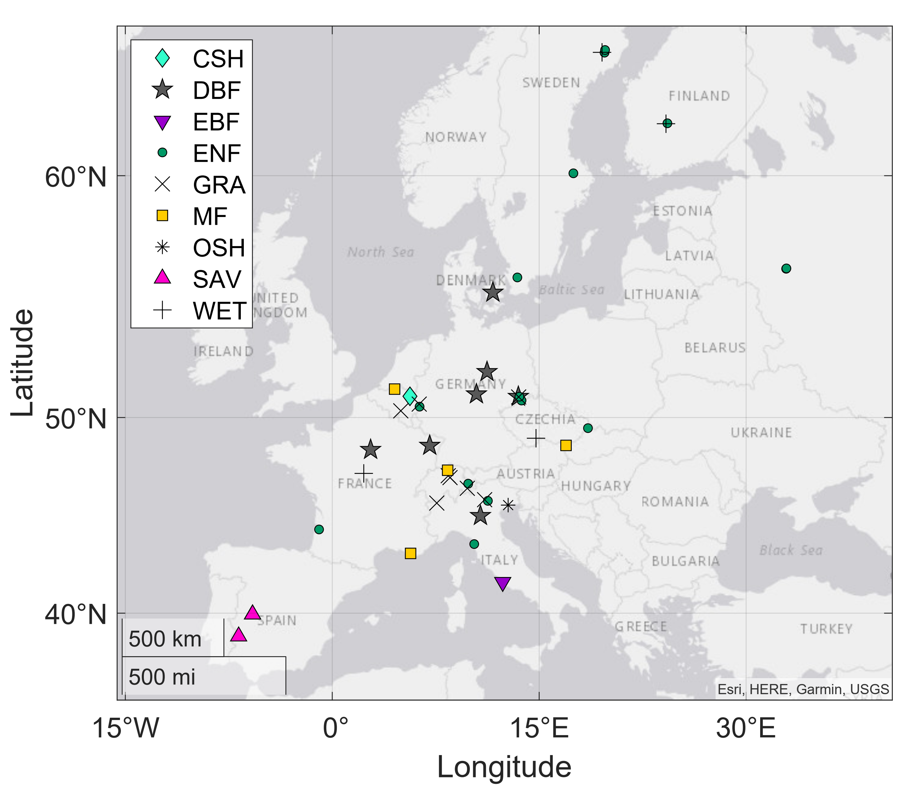
Fig. 1. Location of the 44 eddy covariance flux tower sites in this study. Abbreviations: CSH, closed shrubland; DBF, deciduous broadleaf forest; EBF, evergreen broadleaf forest; ENF, evergreen needleleaf forest; GRA, grassland; MF, mixed forest; OSH, open shrubland; SAV, savannah; WET, wetland.
The majority of our study sites are situated in suburban and rural areas. However, several peri-urban sites are also included, located in close proximity to major European metropolitan areas. These include FR-Fon, situated 50 km from Paris (with a population of 13 million inhabitants); IT-Cp2, located 25 km from Rome (with a population of 4.3 million inhabitants); CH-Cha, CH-Fru and CH-Lae, all within 30 km from Zürich (with a population of 1.4 million inhabitants); DE-Gri, DE-Hzd, DE-Obe and DE-Tha, all located within 30 km from Dresden (with a population of 1.3 million inhabitants); and BE-Bra, situated 13 km from Antwerp (with a population of 1.1 million inhabitants).
The CO₂ flux data used in this study were subjected to quality control and processed using standardized procedures described in Pastorello et al. (2020). At each site, net ecosystem CO₂ exchange (NEE) was filtered using 40 different friction velocity thresholds and gaps in the half-hourly data were filled, resulting in 40 time-series of NEE. The most representative series was selected as the final NEE values. GPP and ecosystem respiration (TER) were derived using daytime and nighttime partitioning methods. In this analysis, we used GPP estimates that were calculated using the temperature response function of nighttime NEE (Reichstein, Stoy, Desai, Lasslop, & Richardson, 2012). The uncertainty of NEE was quantified as the joint uncertainty, which includes both random uncertainty (Hollinger & Richardson, 2005) and the uncertainty associated with friction velocity thresholds. To calculate uncertainty in GPP and TER, only the uncertainty associated with friction velocity thresholds was retained, using the 25th and 75th percentile values of the ensemble generated with 40 friction velocity thresholds. The uncertainty was then summed over the period considered.
In this study, we selected the reference period from March to June of 2015-2019 for several reasons. Firstly, most sites have observational data since 2015, and this period is recent enough to be representative of conditions in 2020. Secondly, using a medium-term averaging period increases the likelihood of obtaining ‘normal’ approximation, which can help to even out short-term swings in a changing climate. The reference period is defined as the average across the years 2015-2019 or specific years for certain sites as listed in Table S1 and described below.
To ensure high quality data for sound comparison and analysis, we further screened the four-month gap-filled NEE data of each year that were available between 2015 and 2020 based on quality flags of 0 to 3. Quality flags of 0, 1, 2, and 3 indicate measured fluxes, good quality, medium quality and poor quality gap-filled NEE, respectively. Specifically, we only included the spring data in which at least 80% of the NEE data had quality flags of 0 to 2. This screening process resulted in a total of 44 sites for this study, with 31 sites providing data for the full study period of 2015-2020 (i.e. six years), 10 sites providing five-year data, two sites providing four-year data, and one site providing two-year data (Table S1).

2.2 Air pollution datasets
To determine ecosystem exposure to pollution, we used hourly air pollutant concentration data simulated by a regional-scale chemical transport model (LOTOS-EUROS) (Manders-Groot et al., 2016), which had a spatial resolution of 0.1° × 0.1°. The simulated pollutants included gaseous species such as ozone (O₃), nitrogen dioxide (NO₂), nitric oxide (NO), ammonia (NH₃), and sulphur dioxide (SO₂), as well as particulate matter (PM), which consisted of secondary inorganic aerosol smaller than 2.5 µm (SIA_{2.5}), particulate matter smaller than 10 μm (PM₁₀) and particulate matter smaller than 2.5 µm (PM_{2.5}). To quantify the relative change before and after lockdown, two calculations were performed: one with "business as usual" emissions, i.e. no COVID-19 reductions were considered, and another with COVID-19 modulated anthropogenic emissions (Guevara et al., 2021). For short vegetation sites (CSH, GRA, OSH, SAV and WET), we used ground level air pollutant concentrations (~2m above surface), while for forests (DBF, EBF, ENF, and MF), we used the concentration at 12.5 m. To obtain half-hourly estimates from the series of hourly concentration that were consistent with the data acquisition frequency for fluxes and meteorological data, we applied a linear interpolation procedure to the series of hourly concentration.

2.3 Diffuse and total radiation
As not all the study sites were equipped with full radiation instruments, we obtained solar radiation components (global SW_{in}, direct SW_{dir} and diffuse SW_{dif}) for all- and clear-sky conditions via the Copernicus Atmosphere Monitoring Service (CAMS) radiation service at 15-min intervals (Gschwind et al., 2019; Lefèvre et al., 2013; Qu et al., 2017) for each site. The UTC date and time were converted to the local time, and we calculated half-hourly irradiance data by averaging the 15-min data. To estimate the proportion of diffuse radiation, we calculated the diffuse radiation fraction (DF) as a ratio of diffuse to global irradiance on the horizontal plane at ground level.

  - Quantification of anomalies
We calculated the anomalies for spring (March-April-May-June) of 2020 as the mean difference between the variables in 2020 (X₂₀₂₀, Y₂₀₂₀) and the reference period from 2015 to 2019 (X_{ref}, Y_{ref}). The anomalies were expressed as both absolute change and relative change, calculated as follows:
ΔX = X₂₀₂₀ – X_{ref} (1)
and
$∆Y=\frac{Y_{2020}-Y_{ref}}{Y_{ref}}×100\%$ (2) A positive anomaly indicates that X and Y during the 2020 spring was higher than during the reference period.

2.5 Statistical analysis
To assess the statistical significance of the differences between the reference and the 2020 data, we used the Student's t-test to test the null hypothesis that the difference between the mean of 2015-2019 and 2020 is zero at the 5% significance level.

2.6 Instantaneous maximal rate of photosynthesis and canopy radiation-use efficiency
We estimated the ecosystem light response parameter (α, γ, P_{max}) by fitting the Michaelis-Menten rectangular hyperbola function (Falge et al., 2001; Lasslop et al., 2010) to half-hourly NEE data (quality flag = 0) from April 20 to May 15 as follows:
$NEE=-\frac{α∙P_{max}∙{SW}_{in}}{α∙{SW}_{in}+P_{max}}+γ$ (3)
Here, NEE (μmol m⁻² s⁻¹) is the net ecosystem CO₂ exchange, α (µmol CO₂ J⁻¹) represents the initial slope of the light-response curve (also known as the canopy radiation-use efficiency), P_{max} (μmol CO₂ m⁻² s⁻¹) denotes the maximum canopy CO₂ uptake rate at light saturation, γ (μmol CO₂ m⁻² s⁻¹) is ecosystem respiration (TER), and SW_{in} (W m⁻²) is the incoming shortwave radiation. To avoid the confounding effect of vapour pressure deficit (VPD) limitation on canopy conductance and photosynthesis, we included only data where the VPD was less than 0.15 kPa in the analysis.

2.7 Multiple linear model and simulation
To investigate the causes of the GPP anomalies, we constructed multivariate models based on spring data from the reference period and compared the estimates from simulations to observed values. Using meteorological variables (SW_{in}, SW_{dif}, T_{a}, VPD) obtained at each site, we built a multivariate model of GPP with a least square regression. We identified the most parsimonious linear model of GPP by applying information criterion techniques via the dredge function of the “MuMIn” package in R (Bartoń, 2020; Tang et al., 2018). The dredge algorithm generates all possible univariate and multivariate models of the response variable (GPP) based on predictors (meteorological and/or pollutant variables) and selects the model with the minimum value of the Akaike information criterion (AIC) − the model with the lowest value of the likelihood function by number of model parameters − as the most parsimonious (Akaike, 1976). We then used this model to predict the 2020 GPP at a daily time scale. In addition to R², we used the normalized root-mean-square error (NRMSE) values computed by the MATLAB “compare” function to assess the model’s fitness by indicating how well the predictions or simulations match the observed data (MathWorks, 2022b). The NRMSE ranges from −∞ to 100%, where 100% indicates a perfect fit, −∞ indicates a poor fit and a fitness value of zero indicates that the identified model is no better than a straight line at matching the observed output.

- RESULTS
3.1 GPP, meteorological and air pollution anomalies during the 2020 spring lockdown
The spring GPP anomaly for 2020, ∆GPP, varied widely among the 44 sites, ranging from −202 to +390 g C m⁻² (−31% to +47%) (Fig. S1). Overall, we observed an increase in both the mean GPP and its standard deviation (+5.3% or +39 g C m⁻², p = .04, and +18%, respectively) (Fig. 2). At 34 out of 44 sites, we found that the 2020 and reference GPP differed significantly at the 5% level. Of these 34 sites, 22 sites showed a positive anomaly ranging from +5.2 to +47%, while 12 sites showed a negative anomaly of −7.1 to −47% (Fig. S1, Table S1). We did not observe marked differences in GPP, meteorological conditions, or pollutant anomalies between peri-urban sites and other sites, and thus we did not analyse them separately (Tables S1, S2 and S3).
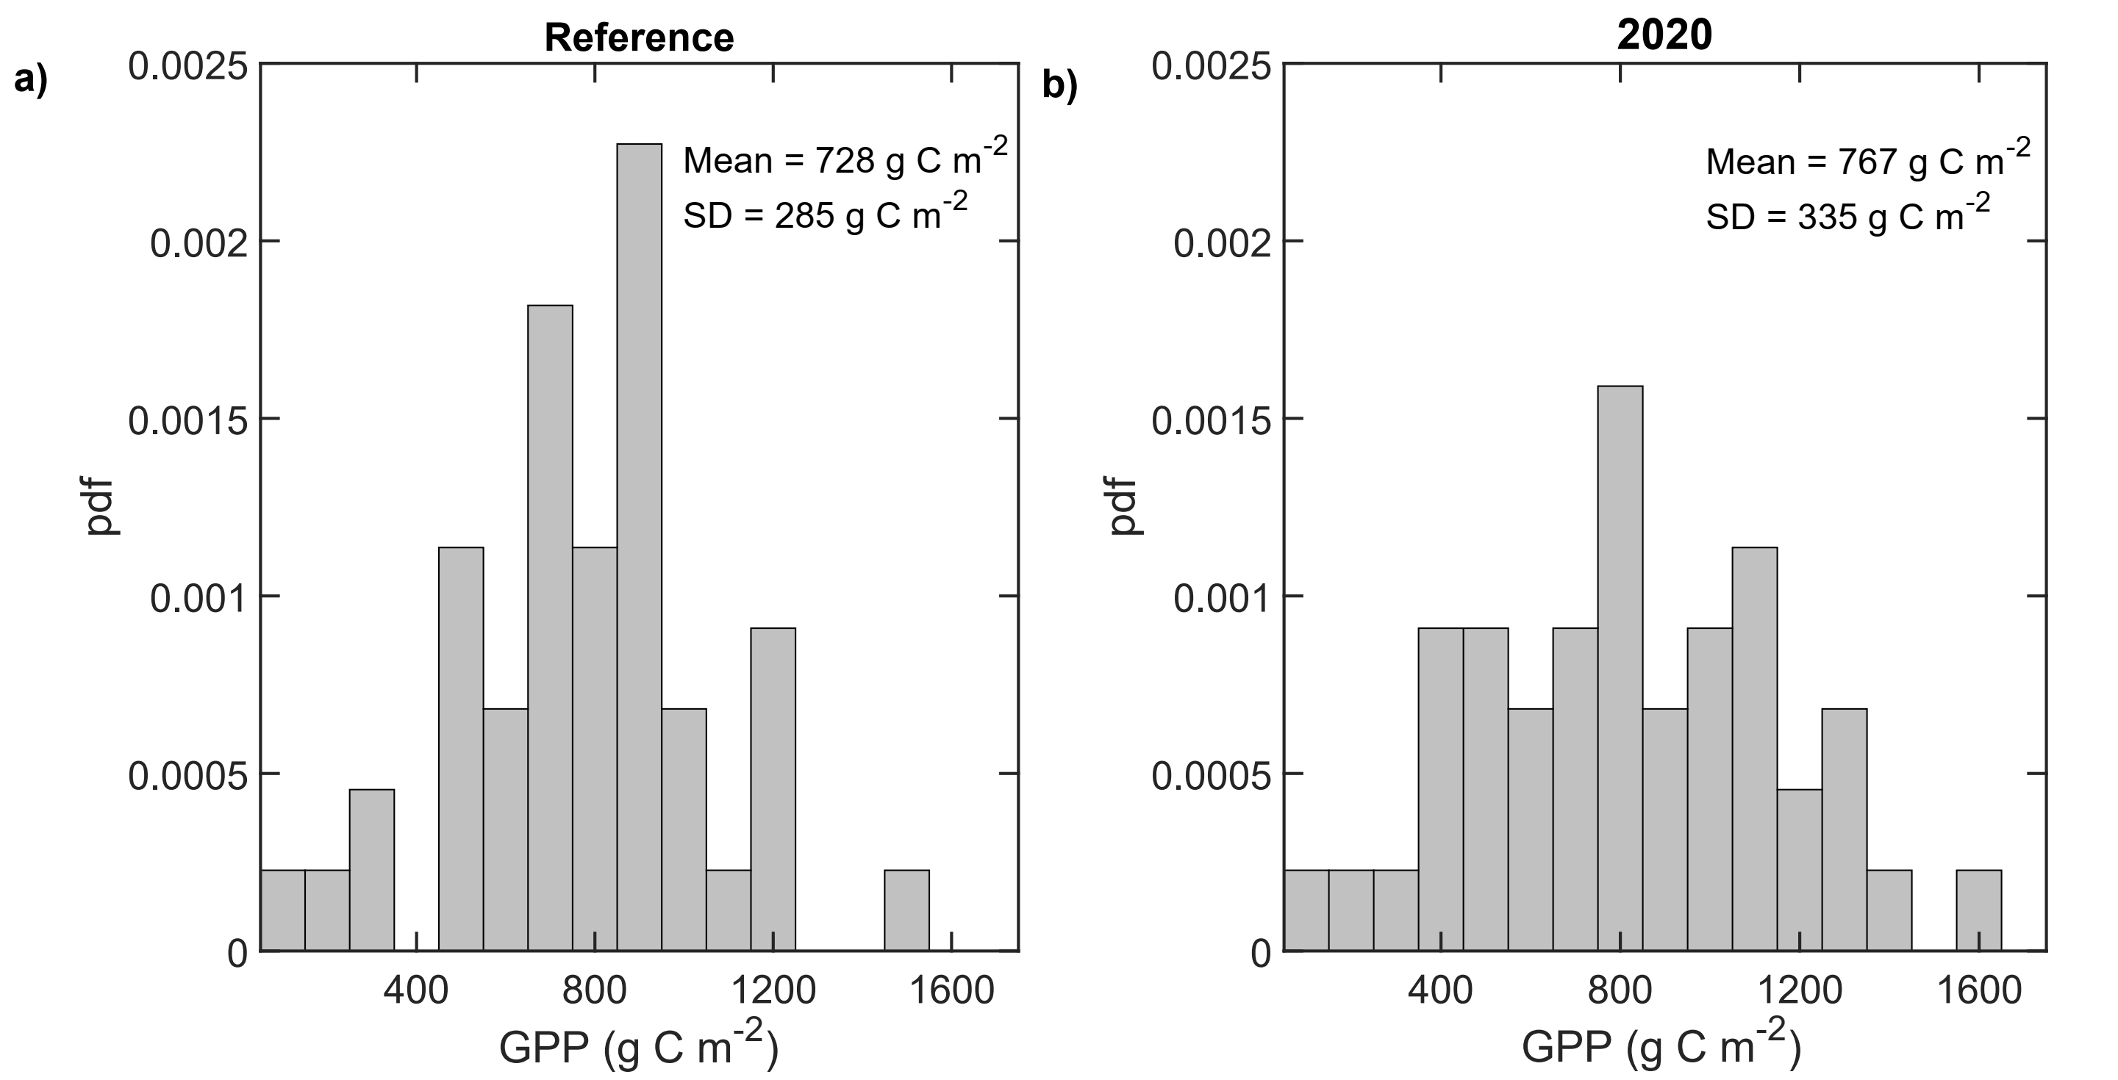Fig. 2. Histogram of probability density function (pdf, y-axis) for gross primary production (GPP, x-axis) across study sites in Europe during the springs of (a) reference years and (b) 2020.
Figure 3 illustrates the difference in the frequency distribution of GPP drivers between the spring 2020 and previous years across the 44 sites. During spring 2020, the GPP distribution shifted towards higher values, coinciding with clearer and drier atmospheric conditions. Specifically, there were increases in SW_{in} (mean ± 1SD: +11 ± 8.9 W m⁻², a relative change of +5.6%, p < .001) and SW_{dir} (+13 ± 12 W m⁻², +12%, p < .001), as well as reductions in SW_{dif} (−2.4 ± 4 W m⁻², −2.8%, p < .001) and diffuse radiation fraction (DF) (−0.04 ± 0.04, −6.4%, p < .001). The ambient concentrations of several air pollutants declined significantly in spring 2020 (p < .001), including NO, NO₂, SIA_{2.5}, PM_{2.5}, PM₁₀ and SO₂, by −0.08 ± 0.09 ppb (−32%), −0.48 ± 0.49 ppb (−26%), −0.64 ± 0.53 µg m⁻³ (−18%), −0.71 ± 0.58 µg m⁻³ (−12%), −0.77 ± 0.61 µg m⁻³ (−7.8%, p < .001) and −0.01 ± 0.01 ppb (−4.5%), respectively. However, there was a small but still significant anomaly of O₃ concentration (−0.72 ± 0.51 ppb, −1.8%, p < .001), despite substantial reductions in its precursors. In contrast, atmospheric NH₃, which is emitted primarily from agricultural activities such as manure and fertilizer application in spring, increased by 1.35% (0.07 ± 0.07 ppb, p < .001).
We analysed the cumulative GPP and driving variables averaged over the 44 sites in spring 2020 and compared them with each previous spring from 2015 to 2019 (Table 1). Our results show that the GPP increased by +26 ± 1.6 (+6.2%), +35 ± 1.7 (+4.9%), +62 ± 5.5 (+8.9%) and +43 ± 2.6 g C m⁻² (+6.1%) compared to the springs of 2015, 2016, 2017 and 2019, respectively. In contrast, a small reduction of −3.4 ± 0.01 g C m⁻² (−0.45%) was observed for 2020 compared to 2018.

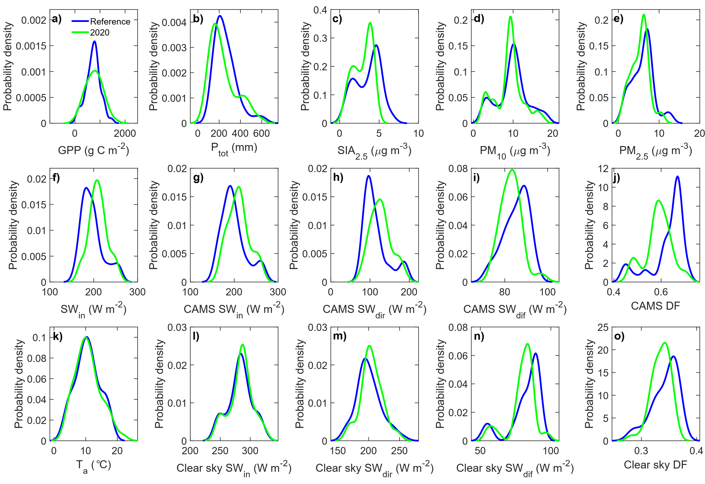
Fig. 3. Comparison of reference (blue line) and 2020 spring (green line) probability density distribution across 44 sites in Europe for (a) GPP (gross primary production), (b) P_{tot} (precipitation), (c) SIA_{2.5} (secondary inorganic aerosol smaller than 2.5 µm), (d) PM₁₀ (particulate matter smaller than 10 µm), (e) PM_{2.5} (particulate matter smaller than 10 µm), (f) SW_{in}, (incoming shortwave radiation, measured on-site), (g) SW_{in} from the Copernicus Atmosphere Monitoring Service (CAMS), (h) CAMS SW_{dir} (direct radiation), (i) CAMS SW_{dif} (diffuse radiation), (j) CAMS DF (diffuse fraction), (k) T_{a} (air temperature), (l) clear sky SW_{in}, (m) clear sky SW_{dir}, (n) clear sky SW_{dif} and (o) clear sky DF.

Table 1. Mean anomalies of cumulative spring (March-June) gross primary production (∆GPP), incoming shortwave radiation (∆SW_{in}) and air temperature (∆T_{a}) between 2020 and individual years from the reference period of 2015-2019.
Year compared | ∆GPP (g C m⁻²) | ∆SW_{in} (W m⁻²) | ∆T_{a} (°C)
2015 | +26 ± 1.6 | +7.6 ± 0.76 | +0.44 ± 0.04
2016 | +35 ± 1.7 | +13 ± 1.7 | +0.58 ± 0.03
2017 | +62 ± 5.5 | +9.0 ± 0.45 | −0.21 ± 0.01
2018 | −3.4 ± 0.01 | +12 ± 0.06 | −0.30 ± 0.01
2019 | +43 ± 2.6 | +7.7 ± 0.29 | −0.91 ± 0.02

3.2 Dependence of GPP anomalies on plant functional type
The positive GPP anomaly was observed in all ecosystems with short vegetation (grassland, savannah and shrubland) and eight out of 11 deciduous broadleaf (DBFs) or mixed forests (MFs). On the other hand, the majority (75%) of evergreen needleleaf forests (ENFs) (9/12 sites) and three DBFs exhibited a negative GPP anomaly. Meanwhile, the sites with no significant change in GPP, ranging from −7% to +4.1%, included all four wetlands (WETs), three ENFs, one grassland site (GRA), one mixed forest (MF) and one open shrubland site (OSH) (Table S2, Fig. S1).
The midday Bowen ratio (β), a ratio of sensible heat flux to latent heat flux, which is directly influenced by stomatal conductance in a given canopy, remained almost unchanged in grassland (GRA), savannah (SAV) and open shrubland (OSH) sites, and was less than 1.0 in 2020. In forests (DBF, EBF, ENF and MF), there was a stronger negative relationship between the anomalies in GPP and β (Fig. 4), suggesting that the 2020 spring GPP in these ecosystems might have been impacted by atmospheric or soil dryness.
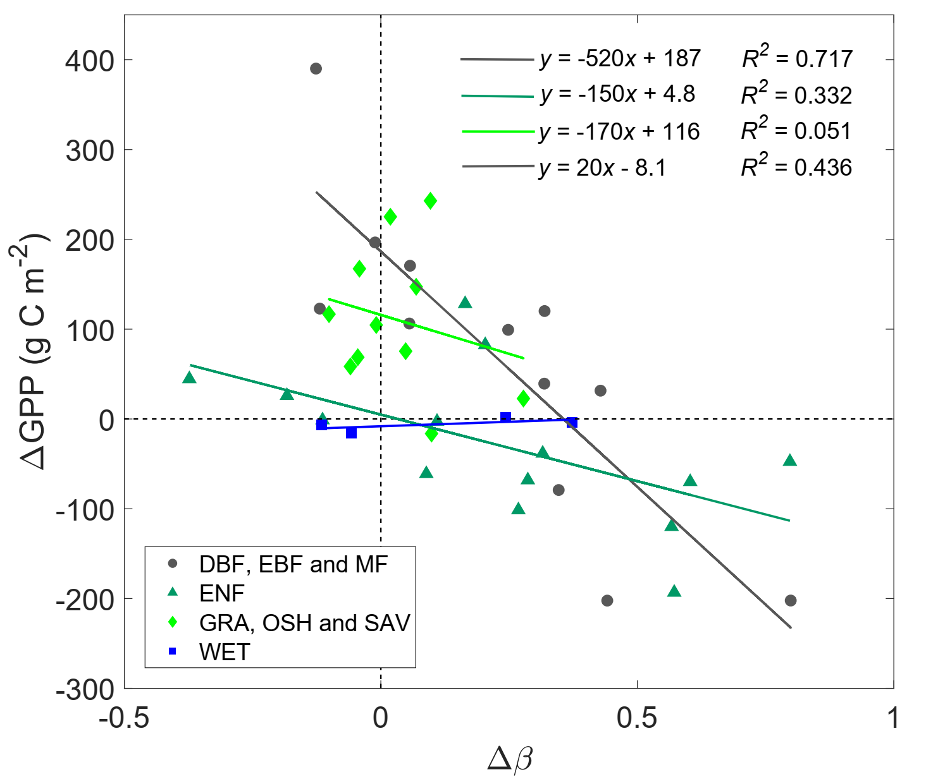
Fig. 4. Relationship between anomalies in gross primary production (∆GPP) and anomalies in Bowen ratio (∆β) across study sites from four classes of plant functional types (PFTs) during the spring of 2020, compared with the reference period. Solid lines represent linear regression lines of each PFT class. Abbreviations for PFTs: DBF, deciduous broadleaf forest; EBF, evergreen broadleaf forest; ENF, evergreen needleleaf forest; GRA, grassland; MF, mixed forest; OSH, open shrubland; SAV, savannah; WET, wetland.

3.3 Attributions of GPP anomalies
To investigate potential mechanisms underlying the GPP anomalies across the 34 sites where the GPP change was significant, we compared the 2020 GPP derived from eddy covariance measurements with the GPP simulated by empirical/semi-empirical models, which were constructed using meteorological and pollutant variables over the reference period for each site (Fig. 5). We categorized these 34 sites into three groups based on the contribution of meteorological and pollutant variables to the models and the occurrence of management operations (Fig 6, Table S4).
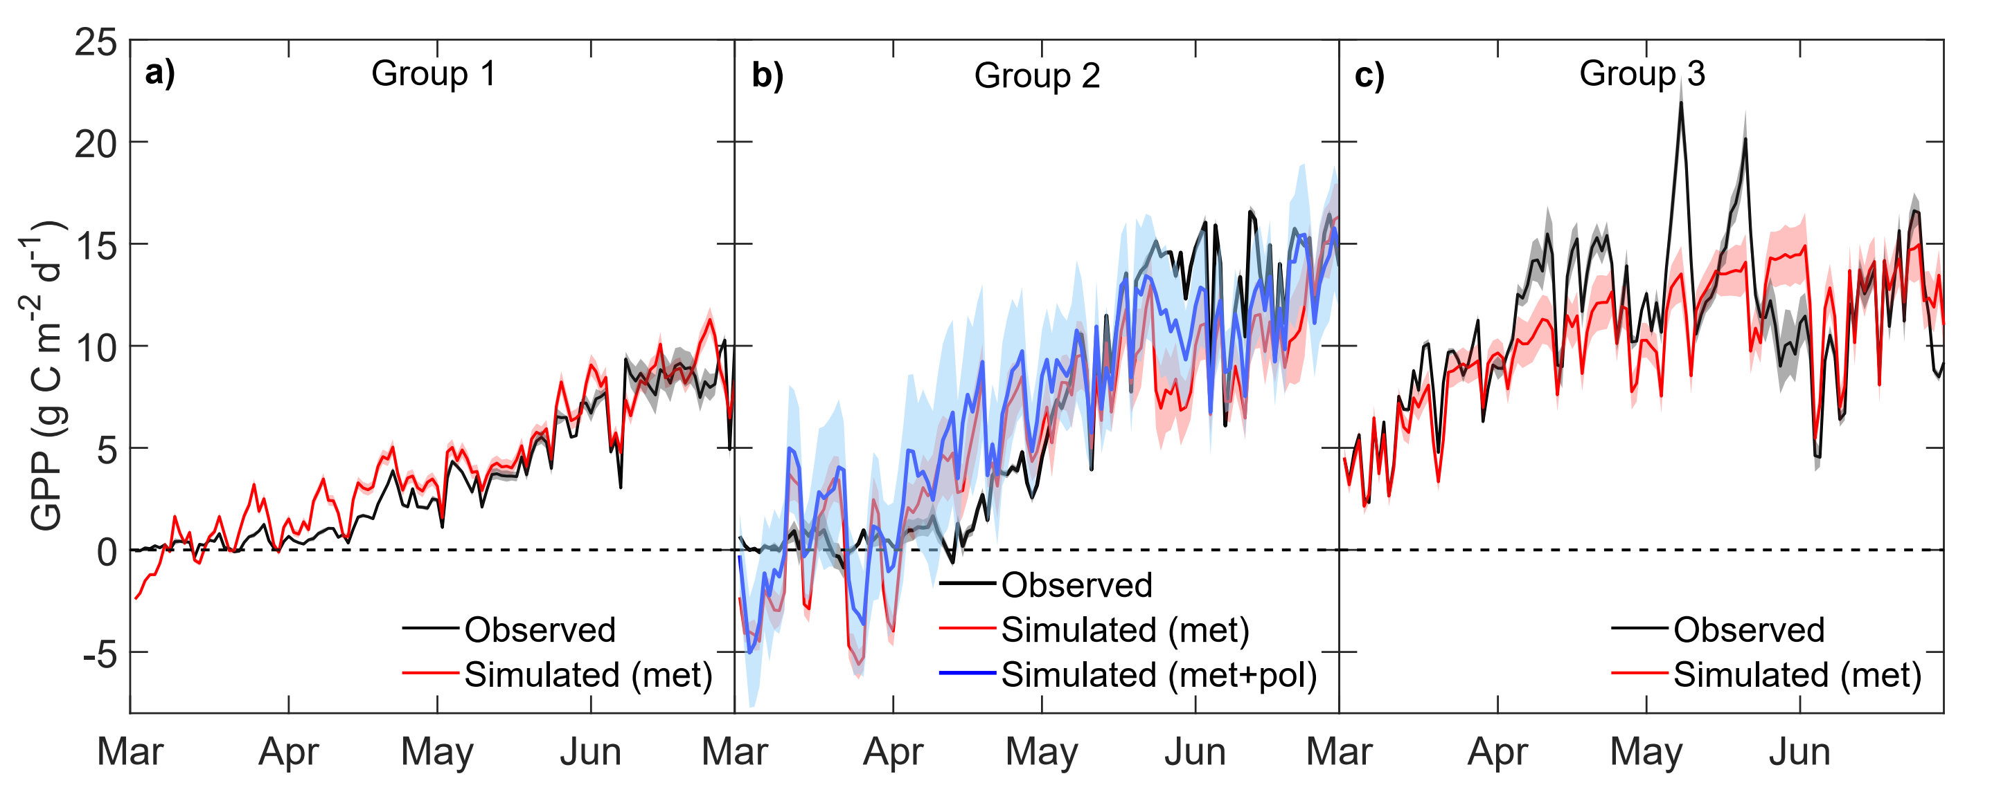
Fig. 5. Classification of study sites into three groups on the basis of model simulation. Comparison of daily GPP values between observation-based estimates (black line) and meteorology-based models (red line, a-c), and meteorology+pollution-based models (blue line, b) from March to June 2020. Shown here are the simulation patterns of each group representative, that is, (a) SE-Svb (ENF) for Group 1, (b) IT-MBo (GRA) for Group 2 and (c) BE-Dor (GRA) for Group 3. GPP anomaly in Group 1 was explained by meteorological variables, Group 2 was attributed to changes in meteorology and pollutants, and Group 3 was driven by both meteorology and management options. Grey shaded areas indicate observation based GPP uncertainty. Red and blue shaded areas represent 95% confidence intervals on model-predicted values.

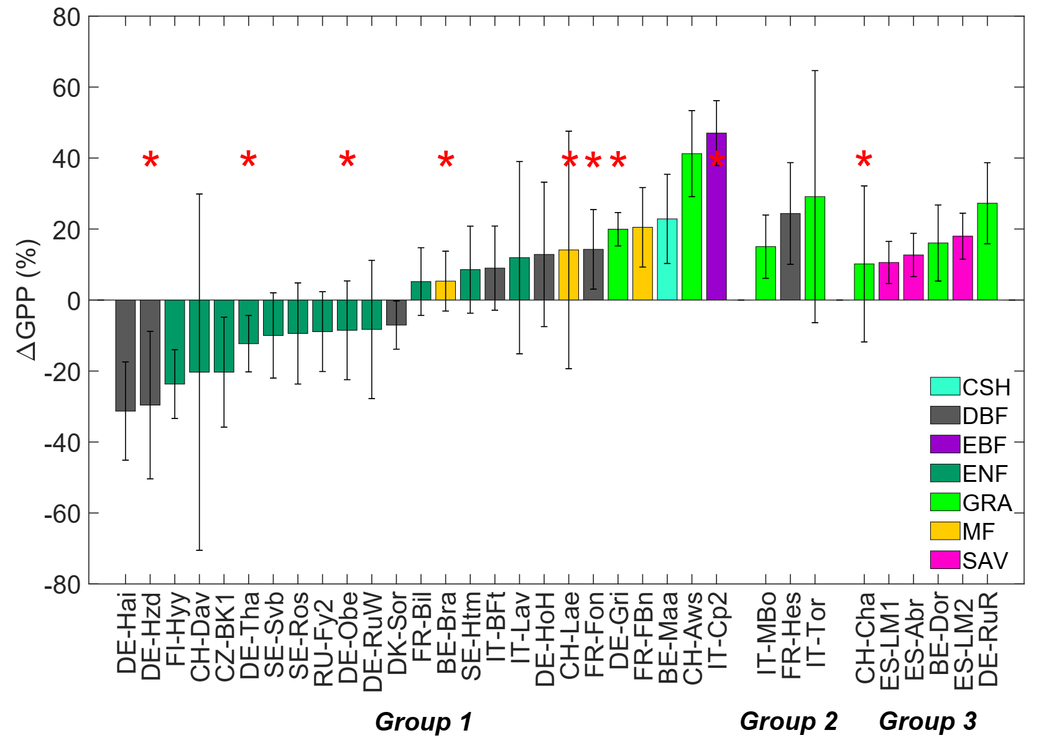
Fig. 6. The distribution of the relative change in GPP in the spring of 2020 (March-June) relative to the spring average for 2015-2019 reference period at the three groups of study sites in Europe. Error bars represent one-sided uncertainty in the GPP anomaly. The stars (*) denote sites close to metropolitan areas (less than 50 km distance) with more than one million inhabitants.

3.3.1 GPP anomalies mostly attributed to meteorology
Group 1 includes 25 sites where meteorology-based model explained > 53% of the variance in GPP (except for CH-Aws, CH-Dav, DE-Hai and DE-Hzd as discussed in Section 4.1 and 4.4), and the pollutant variables did not contribute more than 6% to the total variance (Table S4). This group includes all sites at which no agricultural or forest management occurred in spring 2020. Our results show that 12 out of 25 sites experienced a GPP reduction in the spring of 2020 (−106 ± 60 g C m⁻², −15%) while the remaining 13 sites experienced an increase in GPP (+134 ± 94 g C m⁻², +17%).
In comparison with the reference years 2015-2019, the spring 2020 was brighter, warmer and drier, in which mean SW_{in}, T_{a}, VPD in this group increased by +16 ± 12 W m⁻², +0.24 ± 1.2 °C and +0.06 ± 0.07 kPa respectively, while P_{tot} and SWC decreased by −36 ± 80 mm and −0.04 ± 0.06 m³m⁻³, respectively. The unusual weather conditions during the spring of 2020 emphasize the need to examine eco-physiological responses to climatic drivers, and if possible, to factor out these influences from the overall changes in ecosystem photosynthesis that occurred during the COVID-19 lockdown.
- The reduction in GPP observed in half of the Group 1 sites coincided with an enhanced Bowen ratio, β (+0.55 ± 0.42, +31%, p < .001). The positive anomaly in the β suggested stomatal closure in spring 2020, which corresponded to higher VPD (+0.04 ± 0.05 kPa, +11%, p = .01) and lower SWC (−0.06 ± 0.06 m³ m⁻³, −20%). Furthermore, the mean canopy radiation-use efficiency (α) and the instantaneous maximal rate of photosynthesis (P_{max}) decreased by 0.01 ± 0.02 µmol CO₂ J⁻¹ (−14%, p = .07) and 3.5 ± 3.3 μmol CO₂ m⁻² s⁻¹ (−20%, p = .004), respectively, at these sites. Specifically, the weakening GPP was concurrent with a continuous reduction in SWC at five forests (CH-Dav, DE-Hai, DE-Hzd, DE-Obe and DE-Tha) from summer 2018 to spring 2020 where they reached their minimum (Fig. S2). In addition to precipitation deficits (−45 ± 65 mm, −19%, p = .20), evapotranspiration declined by 44 ± 45 mm (−24%, p = .09) at these five sites. Among the sites in this group with a negative GPP anomaly, the boreal spruce forest (RU-Fy2) is the only site where the relative change of β was 5.9% (which is lower than the other sites that experienced ∆β > 10%). In addition, shortwave irradiance (SW_{in}) decreased by −5.9 W m⁻² (−3.3%, p = .37) coinciding with wetter weather (ΔP_{tot}: +30 mm, +13%, p = .57).
- At the 13 sites from Group 1 which had a positive GPP anomaly, the average increase in β was not significant (+0.17 ± 0.45, +11%, p = .19). A significant increase in SW_{in} was observed at 12 out of 13 sites (+19 ± 12 W m⁻², +9.8%, p < .001), except for an alpine grassland, CH-Aws (1,978 m a.s.l.). This coincides with reduced P_{tot} (−26 ± 85 mm, −9.7%, p = .3), SIA_{2.5} (−0.87 ± 0.62 µg m⁻³, −21%, p < .001), PM_{2.5} (−0.96 ± 0.67 µg m⁻³, −14%, p < .001) and PM₁₀ (−1.0 ± 0.7 µg m⁻³, −9%, p < .001). Further, α and P_{max} increased by +0.02 ± 0.02 µmol CO₂ J⁻¹ (+18%, p = .04) and +2.5 ± 10 μmol CO₂ m⁻² s⁻¹ (+9.3%, p = .4) on average at these sites, respectively.

3.3.2 GPP anomalies attributed to both meteorology and air pollutant concentrations
Group 2 comprises two alpine grasslands, IT-MBo (1,550 m a.s.l.) and IT-Tor (2,160 m a.s.l.), as well as a broadleaf forest, FR-Hes. Our results show that atmospheric pollutants accounted for 12%, 8.7% and 11% of the variance in GPP, and led to an improvement in NRMSE by 11%, 8.3% and 6% at FR-Hes, IT-MBo and IT-Tor, respectively. At FR-Hes and IT-MBo, we observed an increase in SW_{in} (+23 ± 1.9 W m⁻², +11%, p = .04) and a decrease in SW_{dif} (−5 ± 1.2 W m⁻², −5.5%, p = .11) that coincided with reductions in the concentrations of SIA_{2.5} (−1.4 ± 0.98 µg m⁻³, −29%, p = .10), PM_{2.5} (−1.5 ± 0.99 µg m⁻³, −16%, p = .28) and PM₁₀ (−1.6 ± 1.0 µg m⁻³, −13%, p = .27). At FR-Hes, P_{tot} decreased by 82 mm (−25%, p < .01), while IT-MBo received higher P_{tot} (+83 mm, +20%, p < .001). For IT-Tor, mean SW_{in}, SW_{dif}, SIA_{2.5}, PM_{2.5} and PM₁₀ reduced by 2.6 W m⁻² (−1.2%, p = .24), 2.9 W m⁻² (−3.5%, p = .001), 0.97 µg m⁻³ (−20%, p < .001), 1.4 µg m⁻³ (−29%, p < .001) and 0.99 µg m⁻³ (−15%, p < .001) in spring 2020, respectively, while P_{tot} increased by +22 mm (+6.5%, p = .41). There was a substantial increase in α (+0.05 ± 0.03 µmol CO₂ J⁻¹, +74%, p = .12) and P_{max} (+5.8 ± 3.8 μmol CO₂ m⁻² s⁻¹, +51%, p = .12) across all sites. Despite similar relative changes, the concentrations of PM_{2.5} and PM₁₀ at IT-MBo were more than twice as high as those at IT-Tor during both the reference period and the spring of 2020. FR-Hes had the highest concentrations of O₃, SO₂ and NH₃ throughout the study period. We can rule out the potential effects of ecosystem management at these sites, as IT-MBo is a meadow that is extensively managed with low mineral fertilisation and cut once a year in mid-July, while IT-Tor is an unmanaged grassland.

3.3.3 GPP anomalies attributed to both meteorology and management
Group 3 comprises three productive grasslands (GRAs) and three savannahs (SAVs), which were managed using practices such as cutting and fertilizer application (BE-Dor, CH-Cha, DE-RuR), grazing (ES-Abr), or grazing and nutrient manipulation experiment (ES-LM1 and ES-LM2). No forest sites were included in this group. Our results show that meteorological factors accounted for less than 55% of the variability in GPP. In spring 2020, GPP increased at all sites in Group 3 (81 ± 31 g C m⁻², 14%), with GRAs showing a larger increase (+192 ± 48 g C m⁻², +16%) than SAVs (+81 ± 31 g C m⁻², +14%). The difference can be partly attributed to a positive anomaly in SW_{in} at GRAs (+26 ± 6.4 W m⁻², +14%, p = .02), which coincided with a decrease of SW_{dif} (−7.6 ± 2.0 W m⁻², −8.7%, p = .02). In contrast, SAVs showed reduced SW_{in} (−11 ± 4.2 W m⁻², −4.5%, p = .04) and increased SW_{dif} (+6.4 ± 0.76 W m⁻², +8.6%). The negative response of ∆T_{a} on ∆GPP in the SAVs, as opposed to the GRAs (Fig. S3) can be attributed to warmer temperature (+0.46 ± 0.08 °C, +2.7%, p = .01) and decreased water availability (∆P_{tot} = −14 ± 16 mm, −8.1%, p = .27) that led to early senescence in spring 2020, given that the management practices were similar during the study period.

- DISCUSSION
Using a 6-year time series from a network of 44 sites, we were able to detect subtle year-to-year changes in spring gross primary production (GPP) and investigate the factors contributing to these changes. Our study revealed a significant GPP anomaly at 34 out of 44 study sites in Europe, with 12 sites showing a negative anomaly and the remaining 22 sites displaying a positive anomaly. Results showed that the GPP anomaly coincided with changes in soil and atmospheric dryness, solar irradiance, air pollutants and vegetation management. Although the modelling approach was limited to capturing the factors that affected the spring GPP only during the reference period of 2015 to 2019, this analysis enabled us to identify which group of variables - meteorology or pollutants - contributed to the GPP anomaly.

4.1 Drought-related reduction in GPP
Nearly all sites which experienced a GPP decrease in spring 2020 were affected by soil dryness (lower-than-usual SWC) or atmospheric drought (higher-than-usual VPD), as indicated by a significant positive anomaly in Bowen ratio. A strong reduction in evapotranspiration supports the hypothesis of stomatal closure in these ecosystems, mostly forests. However, the considerable decrease in the initial quantum yield (α) suggests that biochemical (non-stomatal) processes also played a role in inhibiting photosynthesis in response to drought stress, in line with previous studies (Escalona, Flexas, & Medrano, 1999; Gourlez de la Motte et al., 2020). Drought events are known to cause reductions in terrestrial ecosystem production (Ciais et al., 2005; Zhao & Running, 2010) through stomatal closure and/or metabolic limitation (Flexas & Medrano, 2002), with effects on GPP that can be either immediate (e.g. stomatal closure) or delayed (e.g. altered hydraulic conductance, metabolic capacity and leaf longevity) (Fu et al., 2022; P. Liu et al., 2019; Pereira et al., 2007; Yu et al., 2022). Indeed, Europe experienced one of the most severe droughts in the 21st century during the summer of 2018 and to a lesser extent 2019 (Bastos et al., 2020; Buras, Rammig, & S. Zang, 2020; Schuldt et al., 2020). The legacy effects of this drought on vegetation might have persisted until 2020 at CH-Dav, DE-Hai, DE-Hzd, DE-Obe and DE-Tha (Fig. 6). Trees are particularly susceptible to insect and pathogen outbreaks under prolonged or extreme drought (Jactel et al., 2012), which can lead to mortality and a shift in forest structure and composition (Li, Wang, Lu, & Yan, 2021). These legacy effects which are not incorporated in the model may explain the relatively large discrepancies between observed and predicted GPP, especially at more severely drought-impacted sites such as CH-Dav, DE-Hai and DE-Hzd (R² < 0.43, NRMSE < 25%). While other sites experienced a negative GPP anomaly due to drought, the afforested peatbog RU-Fy2 was the only site where this anomaly was not linked to dry conditions. Instead, excess rainfall may have created anaerobic conditions that weakened the photosynthetic activity of spruce trees.
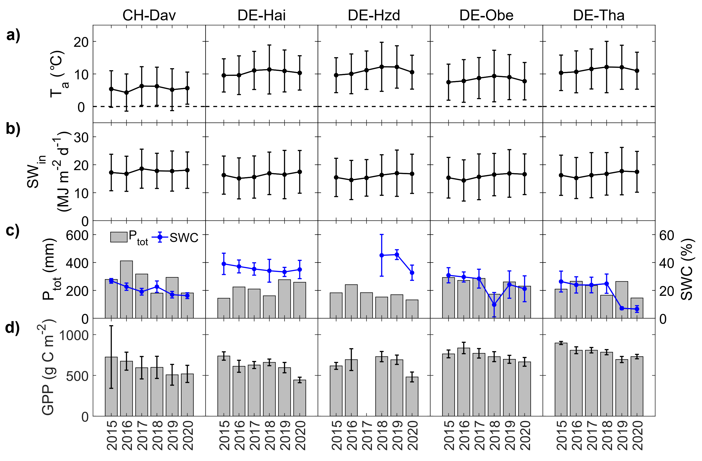
Fig. 6. Interannual variations of spring (averaged or summed from March to June) (a) air temperature (T_{a}), (b) incoming shortwave radiation (SW_{in}), (c) precipitation (P_{tot}) and soil water content (SWC), and (d) gross primary production (GPP) during the study period from 2015 to 2020 at two deciduous broadleaf forests (DE-Hai and DE-Hzd) and three evergreen needleleaf forests (CH-Dav, DE-Obe and DE-Tha) in Group 1. Each error bar denotes a standard deviation.

4.2 Positive GPP anomalies were associated with enhancement in solar irradiance
Our findings indicate that the positive GPP anomaly was primarily driven by enhanced SW_{in}, which outweighed the combined negative effects of increased VPD, reduced P_{tot} and DF. In spring 2020, we observed a main shift in the distribution of the diffuse fraction, from 0.67 to 0.59 for the peak value (Fig. 3j). However, this change is beyond the range where the change in diffuse fraction has a fertilizing effect on GPP, which is typically below 0.45 according to previous studies (Ezhova et al., 2018; Knohl & Baldocchi, 2008; Park et al., 2018). Meanwhile, T_{a} remained almost unchanged from previous springs, and is therefore unlikely to have contributed strongly to the GPP anomaly.
There remains debate as to the extent to which the radiation anomalies should be attributed to changes in aerosol optical depth (i.e. COVID-19 induced changes in anthropogenic pollutant emissions) or the cloudiness. The two factors interact in complex ways since cloud condensation nuclei originate from small (sub-micron) aerosols. A recent study by Voigt et al. (2022) found that the lower aerosol optical thickness during the lockdown led to increased SW_{in} over Europe. The clear sky irradiance anomalies observed in 2020 anomalies (Fig. 3m-o) suggest a decline in aerosol optical depth in spring 2020, but the impact of aerosol concentration on the diffuse fraction of incoming radiation was hardly distinguishable from changes in cloud fraction due to lower atmospheric humidity (Fig. 3b). A combined analysis of ground-based and satellite observations supports the hypothesis that the observed irradiance enhancement was largely due to changes in cloud fraction in Western Europe (van Heerwaarden et al., 2021). Ground observations indicated that cloudiness and aerosol optical depth were both exceptionally low in spring 2020 over Europe.

4.3 Phytotoxic effects of atmospheric pollutants on GPP
In a typical year, O₃ concentrations in spring are usually too low (< 50 ppb on average) to be acutely harmful to plants (Fares et al., 2013), particularly for central-northern European ecosystems when the plants are still dormant and stomatal uptake is not possible. These observations do not support the hypothesis that a change in O₃ mediated the COVID-19 effect on GPP. Furthermore, the small decrease in O₃ concentrations (−1.8%) simulated by LOTOS-EUROS in spring 2020 had a negligible effect on carbon assimilation.
The increases in α and P_{max} in Group 2 (FR-Hes, IT-MBo and IT-Tor) suggest that the stronger plant uptake of CO₂ in 2020 at these sites might be linked to reductions in pollutant exposure or deposition through photosynthesis pathway and/or stomata (Coyne & Bingham, 1978; Philip, 2002). The long-range transboundary transport of air pollutants from the Po Valley has been demonstrated to affect not only the Italian Alpine region, but also other Italian regions and surrounding countries (Carbone et al., 2014; Diémoz, Barnaba, et al., 2019; Diémoz, Gobbi, et al., 2019; Finardi, Silibello, D’Allura, & Radice, 2014; Nyeki et al., 2002). With a population of over 20 million inhabitants, the Po Valley is one of the European pollution hotspots in northern Italy. Due to the valley’s morphology and topography, pollutants are often trapped within the valley, which is enclosed by the Alps on the north and west, and the Apennine on the south. The aerosol particles, mainly of secondary origin from the Po Valley, can form layers that are advected by thermally driven winds or synoptic flows and extend up to 4,000 m a.s.l. on the north-western Alps, implying potential impacts of dry and wet deposition of aerosols on high-altitude ecosystems (Diémoz, Barnaba, et al., 2019; Diémoz, Gobbi, et al., 2019). Similarly, previous studies (Bressi et al., 2014; Sciare et al., 2010; Viatte et al., 2021) have shown that NH₃ and PM_{2.5} originating from the northeast of France, where FR-Hes is located, have a significant impact due to long-range transport over Paris. Our findings are consistent with these studies, as FR-Hes is exposed to agricultural fields in the prevailing wind direction and ranked among the top four or six forest sites with the highest relative reduction in concentrations of PM_{2.5}, PM₁₀ and SO₂, as well as a relative increase in NH₃ concentration. It is important to note that SO₂ oxidizes to form aerosol particles containing sulphate.

  - Limitations and confounding effects: Timing of snow melting, lagged effects and management practices
One limitation of our approach is that the model simulation cannot account for all known drivers of GPP and ecosystem behaviour that occurred during the reference period. This can result in the underestimation or overestimation of GPP. For example, the timing of snow melting at continental locations or upland sites, which is not considered in the models, likely contributes to the divergence observed over nearly the entire duration of spring 2020 for CH-Aws and IT-Tor (R² < 0.53, NRMSE < 32%). Snow cover is a critical factor that affects the phenology and productivity of high-altitude vegetation in the European Alps (Choler, 2015; Xie et al., 2017). The anomalous warm winter 2019-2020 at these sites (T_{a}: +1.7 ± 0.39 ⁰C, +58%, p < .001) resulted in less snowfall and earlier spring melts (Barnett, Adam, & Lettenmaier, 2005), thus advancing the onset of the growing season and extending the carbon uptake period in spring (Desai et al., 2016).
On the other hand, the warm winter experienced in Europe during 2019-2020, as reported by the Copernicus Climate Change Service (2021) had a strong impact on the GPP during the following spring at two Mediterranean sites (FR-FBn and IT-Cp2) (Fig. S4). This extended warming effect made it difficult to use the reference spring data to accurately predict the 2020 spring GPP, resulting in a large divergence between the observed and simulated GPP (Fig. S5a-b). GPP models showed poor fit for these two sites, with negative values of R² and NRMSE (Table S4). We observed a significant improvement in the accuracy of our GPP models for both sites after using preceding winter and/or year-round data from January 2015 to February 2020 as input (R² > 0.76, NRMSE > 51%) (Table S4, Fig. S5c-d). By using a larger dataset that includes more historical information, our models were better able to account for this anomalous warming effect and provide more accurate predictions of GPP. These findings highlight the importance of incorporating relevant and comprehensive data when modelling ecosystem processes.
The Group 3 sites (BE-Dor, CH-Cha, DE-RuR, ES-Abr, ES-LM1 and ES-EM2) were subject to various management practices such as cutting, fertilizer application, grazing and nutrient manipulation experiment (El-Madany et al., 2021; Gharun et al., 2020), which confounded the GPP patterns. As a result, our data driven models cannot entirely explain the observed GPP time course in spring 2020 for these sites (e.g. Fig. 5c) (R² < 0.55, NRMSE < 33%). The addition of pollutant variables slightly increased the variance of the GPP (∆R² < 0.1) and reduced the prediction error (∆NRMSE < 4%) at all sites, except for ES-LM1 and ES-LM2, which had higher R² (0.07 < ∆R² < 0.11) and NRMSE values (4.4% < ∆NRMSE < 6.1%), possibly due to more extensive application of nitrogen and phosphorus fertilizers in the experiment.

- Conclusions
Our first hypothesis that a network of 44 sites could detect the gross primary production (GPP) anomaly in spring 2020 using a 6-year long time series of CO₂ exchange was validated. The results also demonstrate that the enhanced downwelling shortwave radiation played a dominant role in the observed total GPP enhancement, but only in the absence of soil and atmospheric drought, which induced a negative response of GPP. However, the double hypothesis that a large reduction in ozone precursors (i.e. NO_{x}) emissions would (i) reduce ecosystem ozone exposure, and (ii) indirectly reduce its negative impact on GPP was not verified as the temporary altered patterns of deposition of atmospheric pollutants had only a marginal effect on GPP. Although the 2020 lockdown provoked a continent-wide reduction in pollutant emissions in Europe (for a few months only), its major effects on terrestrial GPP may be attributed to the effects of reduced aerosol loadings on the radiation regime. These results highlight the need for concerted policies that address global climate change and mitigation, land resource management, and air quality simultaneously.

Acknowledgement
This work used eddy covariance data acquired and shared by ICOS research infrastructure and site investigators. The eddy covariance data processing and harmonization was carried out by the European Fluxes Database Cluster. A.C.I.T. was funded by the ECODIV research department of INRAE. We would like to thank Tom Taborski for his assistance with the download and processing of CAMS radiation data. We also acknowledge the valuable contributions of the late Werner Eugster.

Data availability statement
Fluxes and meteorological data are available at the ICOS Carbon Portal from https://doi.org/10.18160/2G60-ZHAK; LOTOS-EUROS estimates of air pollution data can be accessed through the Copernicus Atmosphere Monitoring Service https://atmosphere.copernicus.eu/; CAMS radiation data was downloaded from https://www.soda-pro.com/web-services/radiation/cams-radiation-service

References
Akaike, H. (1976). A new look at the statistical model identification. IEEE Transactions on Automatic Control, 19(6), 716–723.
Barnett, T. P., Adam, J. C., & Lettenmaier, D. P. (2005). Potential impacts of a warming climate on water availability in snow-dominated regions. Nature, 438(7066), 303–309. https://doi.org/10.1038/nature04141
Barré, J., Petetin, H., Colette, A., Guevara, M., Peuch, V. H., Rouil, L., … Kouznetsov, R. (2021). Estimating lockdown-induced European NO₂ changes using satellite and surface observations and air quality models. Atmospheric Chemistry and Physics, 21(9), 7373–7394. https://doi.org/10.5194/acp-21-7373-2021
Bartoń, K. (2020). MuMIn: Multi-Model Inference. R package version 1.43.17. Retrieved from https://cran.r-project.org/web/packages/MuMIn/
Bastos, A., Ciais, P., Friedlingstein, P., Sitch, S., Pongratz, J., Fan, L., … Zaehle, S. (2020). Direct and seasonal legacy effects of the 2018 heat wave and drought on European ecosystem productivity. Science Advances, 6(24), 1–14. https://doi.org/10.1126/sciadv.aba2724
Bauwens, M., Compernolle, S., Stavrakou, T., Müller, J. F., van Gent, J., Eskes, H., … Zehner, C. (2020). Impact of Coronavirus Outbreak on NO2 Pollution Assessed Using TROPOMI and OMI Observations. Geophysical Research Letters, 47(11), 1–9. https://doi.org/10.1029/2020GL087978
Bressi, M., Sciare, J., Ghersi, V., Mihalopoulos, N., Petit, J. E., Nicolas, J. B., … Theodosi, C. (2014). Sources and geographical origins of fine aerosols in Paris (France). Atmospheric Chemistry and Physics, 14(16), 8813–8839. https://doi.org/10.5194/acp-14-8813-2014
Buras, A., Rammig, A., & S. Zang, C. (2020). Quantifying impacts of the 2018 drought on European ecosystems in comparison to 2003. Biogeosciences, 17(6), 1655–1672. https://doi.org/10.5194/bg-17-1655-2020
Carbone, C., Decesari, S., Paglione, M., Giulianelli, L., Rinaldi, M., Marinoni, A., … Facchini, M. C. (2014). 3-year chemical composition of free tropospheric PM1 at the Mt. Cimone GAW global station - South Europe - 2165m a.s.l. Atmospheric Environment, 87, 218–227. https://doi.org/10.1016/j.atmosenv.2014.01.048
Choler, P. (2015). Growth response of temperate mountain grasslands to inter-annual variations in snow cover duration. Biogeosciences, 12(12), 3885–3897. https://doi.org/10.5194/bg-12-3885-2015
Ciais, P., Reichstein, M., Viovy, N., Granier, A., Ogée, J., Allard, V., … Valentini, R. (2005). Europe-wide reduction in primary productivity caused by the heat and drought in 2003. Nature, 437(7058), 529–533. https://doi.org/10.1038/nature03972
Copernicus: 2020 warmest year on record for Europe; globally, 2020 ties with 2016 for warmest year recorded. (2021). Retrieved from Copernicus Climate Change Service website: https://climate.copernicus.eu/copernicus-2020-warmest-year-record-europe-globally-2020-ties-2016-warmest-year-recorded
Coyne, P. I., & Bingham, G. E. (1978). Photosynthesis and Stomatal Light Responses in Snap Beans Exposed to Hydrogen Sulfide and Ozone. Journal of the Air Pollution Control Association, 28(11), 1119–1123. https://doi.org/10.1080/00022470.1978.10470715
Desai, A. R., Wohlfahrt, G., Zeeman, M. J., Katata, G., Eugster, W., Montagnani, L., … Schmid, H. P. (2016). Montane ecosystem productivity responds more to global circulation patterns than climatic trends. Environmental Research Letters, 11(2). https://doi.org/10.1088/1748-9326/11/2/024013
Diémoz, H., Barnaba, F., Magri, T., Pession, G., Dionisi, D., Pittavino, S., … Gobbi, G. P. (2019). Transport of Po Valley aerosol pollution to the northwestern Alps-Part 1: Phenomenology. Atmospheric Chemistry and Physics, 19(5), 3065–3095. https://doi.org/10.5194/acp-19-3065-2019
Diémoz, H., Gobbi, G. P., Magri, T., Pession, G., Pittavino, S., Tombolato, I. K. F., … Barnaba, F. (2019). Transport of Po Valley aerosol pollution to the northwestern Alps – Part 2: Long-term impact on air quality Henri. Atmospheric Chemistry and Physics, 19(5), 10129–10160. https://doi.org/10.5194/acp-19-3065-2019
El-Madany, T. S., Reichstein, M., Carrara, A., Martín, M. P., Moreno, G., Gonzalez-Cascon, R., … Migliavacca, M. (2021). How Nitrogen and Phosphorus Availability Change Water Use Efficiency in a Mediterranean Savanna Ecosystem. Journal of Geophysical Research: Biogeosciences, 126(5). https://doi.org/10.1029/2020JG006005
Escalona, J. M., Flexas, J., & Medrano, H. (1999). Stomatal and non-stomatal limitations of photosynthesis under water stress in field-grown grapevines. Australian Journal of Plant Physiology, 26, 421–433.
Falge, E., Baldocchi, D., Olson, R., Anthoni, P., Aubinet, M., Bernhofer, C., … Wofsy, S. (2001). Gap filling strategies for defensible annual sums of net ecosystem exchange. Agricultural and Forest Meteorology, 107(1), 43–69. https://doi.org/10.1016/S0168-1923(00)00225-2
Fares, S., Vargas, R., Detto, M., Goldstein, A. H., Karlik, J., Paoletti, E., & Vitale, M. (2013). Tropospheric ozone reduces carbon assimilation in trees: Estimates from analysis of continuous flux measurements. Global Change Biology, 19(8), 2427–2443. https://doi.org/10.1111/gcb.12222
Finardi, S., Silibello, C., D’Allura, A., & Radice, P. (2014). Analysis of pollutants exchange between the Po Valley and the surrounding European region. Urban Climate, 10, 682–702. https://doi.org/10.1016/j.uclim.2014.02.002
Flexas, J., & Medrano, H. (2002). Drought-inhibition of photosynthesis in C3 plants: Stomatal and non-stomatal limitations revisited. Annals of Botany, 89(2), 183–189. https://doi.org/10.1093/aob/mcf027
Fu, Z., Ciais, P., Prentice, I. C., Gentine, P., Makowski, D., Bastos, A., … Hajima, T. (2022). Atmospheric dryness reduces photosynthesis along a large range of soil water deficits. Nature Communications, 13(1), 1–10. https://doi.org/10.1038/s41467-022-28652-7
Gharun, M., Hörtnagl, L., Paul-Limoges, E., Ghiasi, S., Feigenwinter, I., Burri, S., … Buchmann, N. (2020). Physiological response of Swiss ecosystems to 2018 drought across plant types and elevation: Summer 2018 drought in Switzerland. Philosophical Transactions of the Royal Society B: Biological Sciences, 375(1810). https://doi.org/10.1098/rstb.2019.0521
Gourlez de la Motte, L., Beauclaire, Q., Heinesch, B., Cuntz, M., Foltýnová, L., Šigut, L., … Longdoz, B. (2020). Non-stomatal processes reduce gross primary productivity in temperate forest ecosystems during severe edaphic drought: Edaphic drought in forest ecosystems. Philosophical Transactions of the Royal Society B: Biological Sciences, 375(1810). https://doi.org/10.1098/rstb.2019.0527
Grene, R. (2002). Oxidative Stress and Acclimation Mechanisms in Plants. The Arabidopsis Book, 1, e0036. https://doi.org/10.1199/tab.0036.1
Gschwind, B., Wald, L., Blanc, P., Lefèvre, M., Schroedter-Homscheidt, M., & Arola, A. (2019). Improving the McClear model estimating the downwelling solar radiation at ground level in cloud-free conditions - McClear-v3. Meteorologische Zeitschrift, 28(2), 147–163. https://doi.org/10.1127/metz/2019/0946
Guevara, M., Jorba, O., Soret, A., Petetin, H., Bowdalo, D., Serradell, K., … Pérez Garciá-Pando, C. (2021). Time-resolved emission reductions for atmospheric chemistry modelling in Europe during the COVID-19 lockdowns. Atmospheric Chemistry and Physics, 21(2), 773–797. https://doi.org/10.5194/acp-21-773-2021
Guevara, M., Petetin, H., Jorba, O., Denier Van Der Gon, H., Kuenen, J., Super, I., … Perez Garcia-Pando, C. (2022). European primary emissions of criteria pollutants and greenhouse gases in 2020 modulated by the COVID-19 pandemic disruptions. Earth System Science Data, 14(6), 2521–2552. https://doi.org/10.5194/essd-14-2521-2022
Hollinger, D. Y., & Richardson, A. D. (2005). Uncertainty in eddy covariance measurements and its application to physiological models. Tree Physiology, 25(7), 873–885. https://doi.org/10.1093/treephys/25.7.873
Jactel, H., Petit, J., Desprez-Loustau, M. L., Delzon, S., Piou, D., Battisti, A., & Koricheva, J. (2012). Drought effects on damage by forest insects and pathogens: A meta-analysis. Global Change Biology, 18(1), 267–276. https://doi.org/10.1111/j.1365-2486.2011.02512.x
Lasslop, G., Reichstein, M., Papale, D., Richardson, A., Arneth, A., Barr, A., … Wohlfahrt, G. (2010). Separation of net ecosystem exchange into assimilation and respiration using a light response curve approach: Critical issues and global evaluation. Global Change Biology, 16(1), 187–208. https://doi.org/10.1111/j.1365-2486.2009.02041.x
Lefèvre, M., Oumbe, A., Blanc, P., Espinar, B., Gschwind, B., Qu, Z., … Morcrette, J. J. (2013). McClear: A new model estimating downwelling solar radiation at ground level in clear-sky conditions. Atmospheric Measurement Techniques, 6(9), 2403–2418. https://doi.org/10.5194/amt-6-2403-2013
Li, X., Wang, Y. P., Lu, X., & Yan, J. (2021). Diagnosing the impacts of climate extremes on the interannual variations of carbon fluxes of a subtropical evergreen mixed forest. Agricultural and Forest Meteorology, 307, 108507. https://doi.org/10.1016/j.agrformet.2021.108507
Liu, P., Zha, T., Jia, X., Black, T. A., Jassal, R. S., Ma, J., … Wu, Y. (2019). Different Effects of Spring and Summer Droughts on Ecosystem Carbon and Water Exchanges in a Semiarid Shrubland Ecosystem in Northwest China. Ecosystems, 22(8), 1869–1885. https://doi.org/10.1007/s10021-019-00379-5
Liu, S., Xing, J., Zhao, B., Wang, J., Wang, S., Zhang, X., & Ding, A. (2019). Understanding of Aerosol–Climate Interactions in China: Aerosol Impacts on Solar Radiation, Temperature, Cloud, and Precipitation and Its Changes Under Future Climate and Emission Scenarios. Current Pollution Reports. https://doi.org/10.1007/s40726-019-00107-6
Manders-Groot, A. M. M., Segers, A. J., Jonkers, S., Schaap, M., Timmermans, R., Hendriks, C., … Banzhaf, S. (2016). LOTOS-EUROS v2.0 Reference Guide. TNO Report 2016 R10898, 77.
MathWorks. (n.d.). Compare identified model output with measured output. Retrieved from https://www.mathworks.com/help/ident/ref/compare.html
Menut, L., Bessagnet, B., Siour, G., Mailler, S., Pennel, R., & Cholakian, A. (2020). Impact of lockdown measures to combat Covid-19 on air quality over western Europe. Science of the Total Environment, 741, 140426. https://doi.org/10.1016/j.scitotenv.2020.140426
Mercado, L. M., Bellouin, N., Sitch, S., Boucher, O., Huntingford, C., Wild, M., & Cox, P. M. (2009). Impact of changes in diffuse radiation on the global land carbon sink. Nature, 458(7241), 1014–1017. https://doi.org/10.1038/nature07949
Nyeki, S., Eleftheriadis, K., Baltensperger, U., Colbeck, I., Fiebig, M., Fix, A., … Petzold, A. (2002). Airborne lidar and in-situ aerosol observations of an elevated layer, leeward of the european alps and apennines. Geophysical Research Letters, 29(17), 3–6. https://doi.org/10.1029/2002GL014897
Ordóñez, C., Garrido-Perez, J. M., & García-Herrera, R. (2020). Early spring near-surface ozone in Europe during the COVID-19 shutdown: Meteorological effects outweigh emission changes. Science of the Total Environment, 747(December 2019), 141322. https://doi.org/10.1016/j.scitotenv.2020.141322
Pastorello, G., Trotta, C., Canfora, E., Chu, H., Christianson, D., Cheah, Y. W., … Papale, D. (2020). The FLUXNET2015 dataset and the ONEFlux processing pipeline for eddy covariance data. Scientific Data, 7(1), 225. https://doi.org/10.1038/s41597-020-0534-3
Pell, E. J., Schlagnhaufer, C. D., & Arteca, R. N. (1997). Ozone-induced oxidative stress: Mechanisms of action and reaction. Physiologia Plantarum, 100(2), 264–273. https://doi.org/10.1034/j.1399-3054.1997.1000207.x
Pereira, J. S., Mateus, J. A., Aires, L. M., Pita, G., Pio, C., David, J. S., … Rodrigues, A. (2007). Net ecosystem carbon exchange in three contrasting Mediterranean ecosystems - The effect of drought. Biogeosciences, 4(5), 791–802. https://doi.org/10.5194/bg-4-791-2007
Philip, E. (2002). Effects of low concentrations of SO₂ and NO_{X} on the photosynthetic characteristics of Pongamia pinnata. Journal of Tropical Forest Science, 14(4), 474–484.
Putaud, J. P., Pozzoli, L., Pisoni, E., Martins Dos Santos, S., Lagler, F., Lanzani, G., … Colette, A. (2021). Impacts of the COVID-19 lockdown on air pollution at regional and urban background sites in northern Italy. Atmospheric Chemistry and Physics, 21(10), 7597–7609. https://doi.org/10.5194/acp-21-7597-2021
Qu, Z., Oumbe, A., Blanc, P., Espinar, B., Gesell, G., Gschwind, B., … Wald, L. (2017). Fast radiative transfer parameterisation for assessing the surface solar irradiance: The Heliosat-4 method. Meteorologische Zeitschrift, 26(1), 33–57. https://doi.org/10.1127/metz/2016/0781
Reichstein, M., Stoy, P. C., Desai, A. R., Lasslop, G., & Richardson, A. D. (2012). Partitioning of net fluxes. In M. Aubinet, T. Vesala, & D. Papale (Eds.), Eddy Covariance. https://doi.org/https://doi.org/10.1007/978-94-007-2351-1_9
Roderick, M. L., Farquhar, G. D., Berry, S. L., & Noble, I. R. (2001). On the direct effect of clouds and atmospheric particles on the productivity and structure of vegetation. Oecologia, 129(1), 21–30. https://doi.org/10.1007/s004420100760
Schuldt, B., Buras, A., Arend, M., Vitasse, Y., Beierkuhnlein, C., Damm, A., … Kahmen, A. (2020). A first assessment of the impact of the extreme 2018 summer drought on Central European forests. Basic and Applied Ecology, 45, 86–103. https://doi.org/10.1016/j.baae.2020.04.003
Sciare, J., D’Argouges, O., Zhang, Q. J., Sarda-Estève, R., Gaimoz, C., Gros, V., … Sanchez, O. (2010). Comparison between simulated and observed chemical composition of fine aerosols in Paris (France) during springtime: Contribution of regional versus continental emissions. Atmospheric Chemistry and Physics, 10(24), 11987–12004. https://doi.org/10.5194/acp-10-11987-2010
Tang, A. C. I., Stoy, P. C., Hirata, R., Musin, K. K., Aeries, E. B., Wenceslaus, J., & Melling, L. (2018). Eddy Covariance Measurements of Methane Flux at a Tropical Peat Forest in Sarawak, Malaysian Borneo. Geophysical Research Letters, 45(9), 4390–4399. https://doi.org/10.1029/2017GL076457
Turnock, S. T., Butt, E. W., Richardson, T. B., Mann, G. W., Reddington, C. L., Forster, P. M., … Spracklen, D. V. (2016). The impact of European legislative and technology measures to reduce air pollutants on air quality, human health and climate. Environmental Research Letters, 11(2). https://doi.org/10.1088/1748-9326/11/2/024010
van Heerwaarden, C. C., Mol, W. B., Veerman, M. A., Benedict, I., Heusinkveld, B. G., Knap, W. H., … Fiedler, S. (2021). Record high solar irradiance in Western Europe during first COVID-19 lockdown largely due to unusual weather. Communications Earth & Environment, 2(1), 1–7. https://doi.org/10.1038/s43247-021-00110-0
Venter, Z. S., Aunan, K., Chowdhury, S., & Lelieveld, J. (2020). COVID-19 lockdowns cause global air pollution declines. Proceedings of the National Academy of Sciences of the United States of America, 117(32), 18984–18990. https://doi.org/10.1073/pnas.2006853117
Viatte, C., Petit, J. E., Yamanouchi, S., Van Damme, M., Doucerain, C., Germain-Piaulenne, E., … Clerbaux, C. (2021). Ammonia and pm2.5 air pollution in paris during the 2020 covid lockdown. Atmosphere, 12(2), 1–18. https://doi.org/10.3390/atmos12020160
Voigt, C., Lelieveld, J., Schlager, H., Schneider, J., Curtius, J., Meerkötter, R., … Rapp, M. (2022). Cleaner Skies during the COVID-19 Lockdown. Bulletin of the American Meteorological Society, 103(8), E1796–E1827. https://doi.org/10.1175/BAMS-D-21-0012.1
Wang, X., Wu, J., Chen, M., Xu, X., Wang, Z., Wang, B., … Liu, L. (2018). Field evidences for the positive effects of aerosols on tree growth. Global Change Biology, 24(10), 4983–4992. https://doi.org/10.1111/gcb.14339
Warm Winter 2020 Team & ICOS Ecosystem Thematic Centre. (2022). Warm Winter 2020 ecosystem eddy covariance flux product for 73 stations in FLUXNET-Archive format—release 2022-1 (Version 1.0). Retrieved from ICOS Carbon Portal website: https://doi.org/10.18160/2G60-ZHAK
Wittig, V. E., Ainsworth, E. A., Naidu, S. L., Karnosky, D. F., & Long, S. P. (2009). Quantifying the impact of current and future tropospheric ozone on tree biomass, growth, physiology and biochemistry: A quantitative meta-analysis. Global Change Biology, 15(2), 396–424. https://doi.org/10.1111/j.1365-2486.2008.01774.x
Wong, S. C., Cowan, I. R., & Farquhar, G. D. (1979). Stomatal conductance correlates with photosynthetic capacity. Nature, 282(5737), 424–426. https://doi.org/10.1038/282424a0
World Health Organisation. (2020). WHO Director-General’s opening remarks at the media briefing on COVID-19 - 13 March 2020. Retrieved from https://www.who.int/director-general/speeches/detail/who-director-general-s-opening-remarks-at-the-mission-briefing-on-covid-19---13-march-2020
Xie, J., Kneubühler, M., Garonna, I., Notarnicola, C., De Gregorio, L., De Jong, R., … Schaepman, M. E. (2017). Altitude-dependent influence of snow cover on alpine land surface phenology. Journal of Geophysical Research: Biogeosciences, 122(5), 1107–1122. https://doi.org/10.1002/2016JG003728
Yu, X., Orth, R., Reichstein, M., Bahn, M., Klosterhalfen, A., Knohl, A., & Koebsch, F. (2022). Contrasting drought legacy effects on gross primary productivity in a mixed versus pure beech forest. 19, 4315–4329.
Zhao, M., & Running, S. W. (2010). Drought-induced reduction in global terrestrial net primary production from 2000 through 2009. Science, 329(5994), 940–943. https://doi.org/10.1126/science.334.6062.1496

